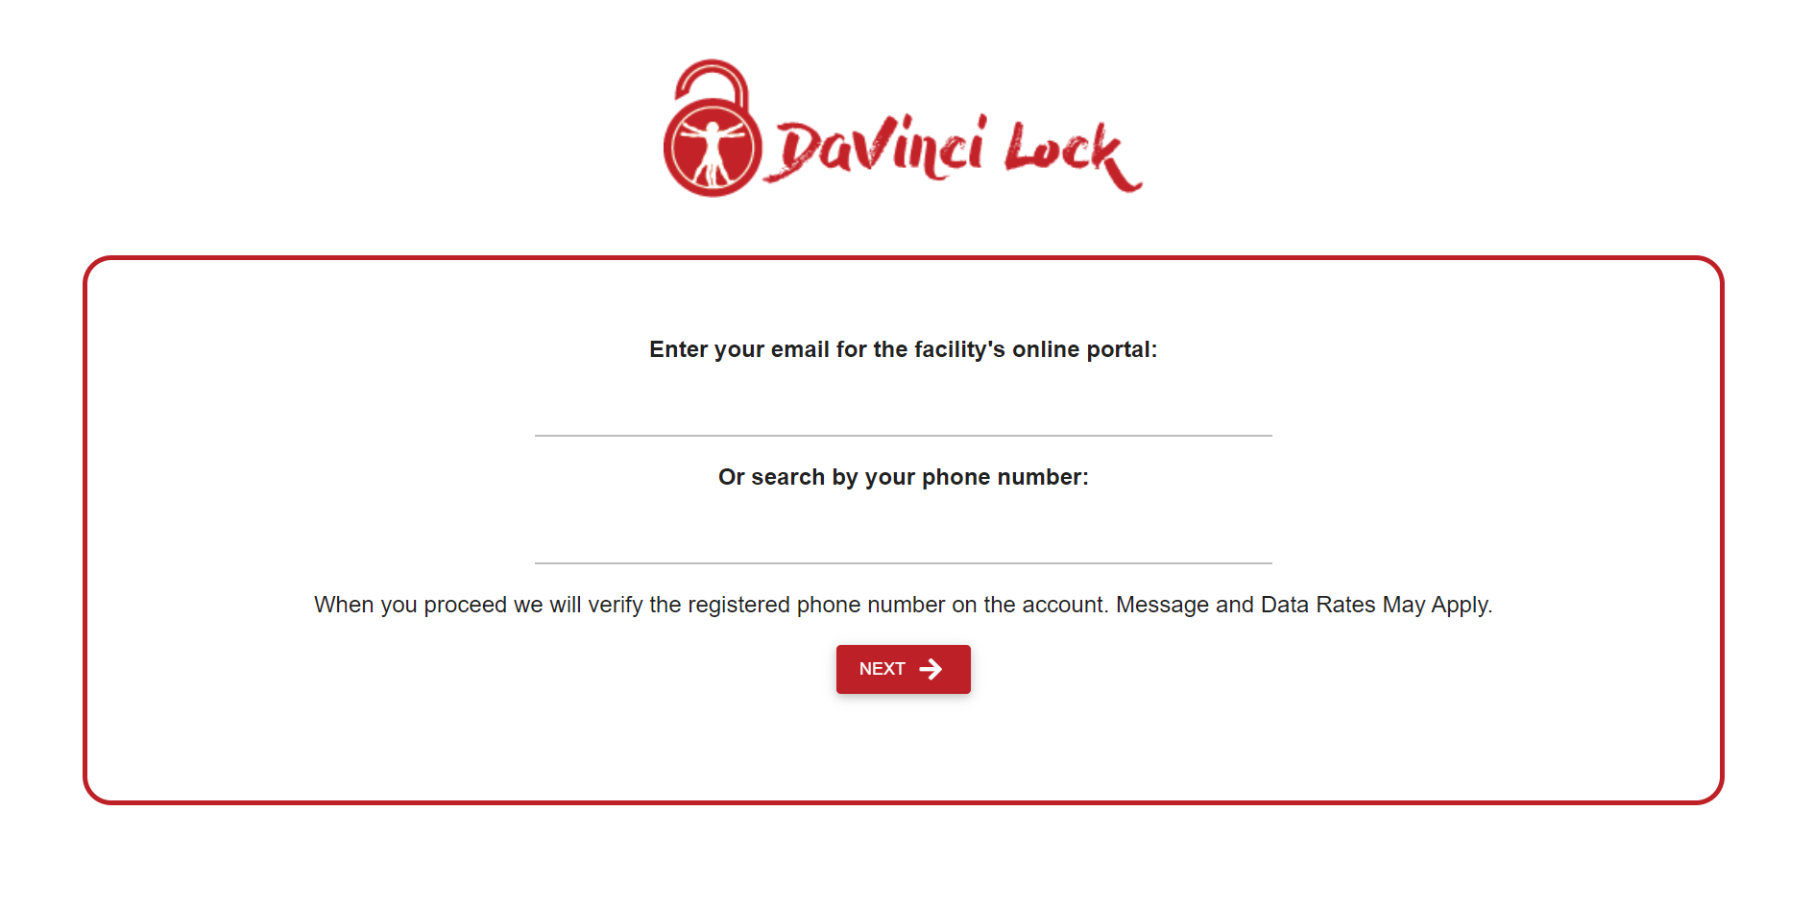

Enter your email address or cell # that is on file

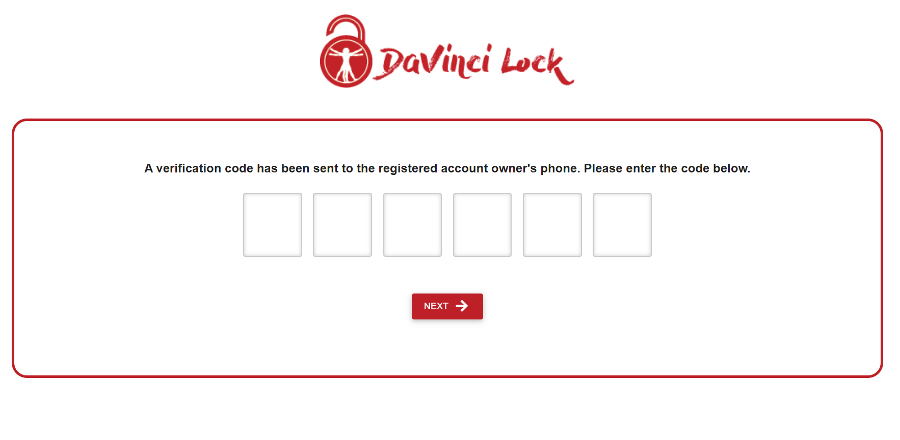

You will get a text message with a code

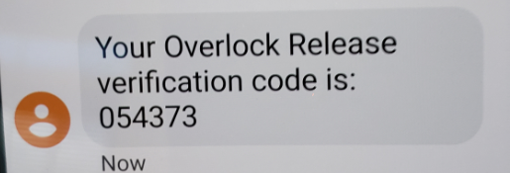

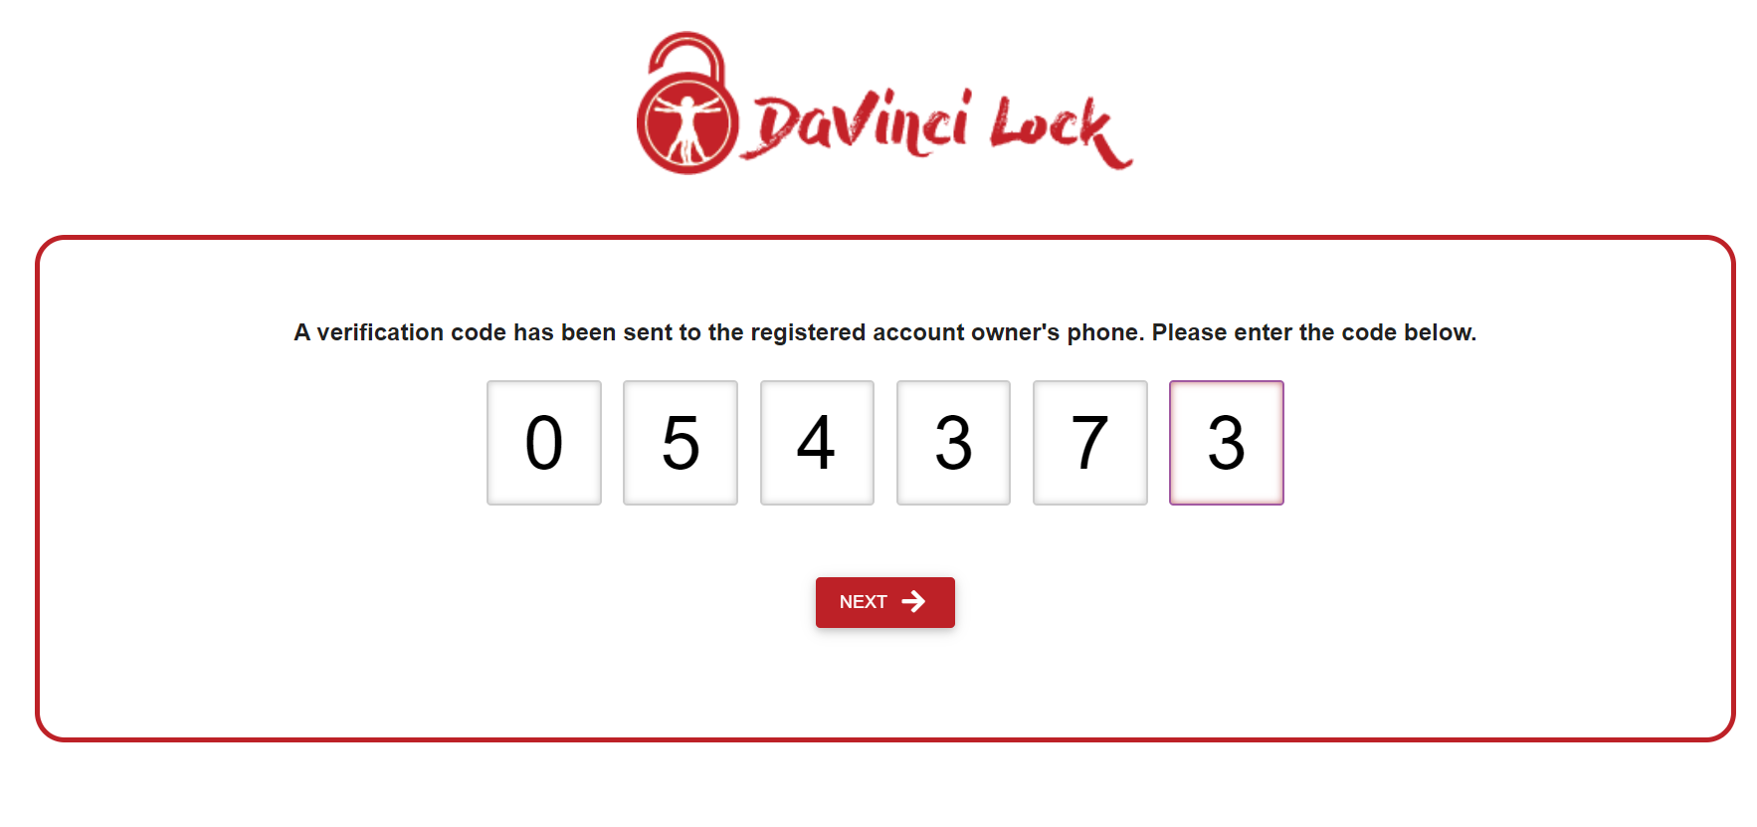

Select your current unit

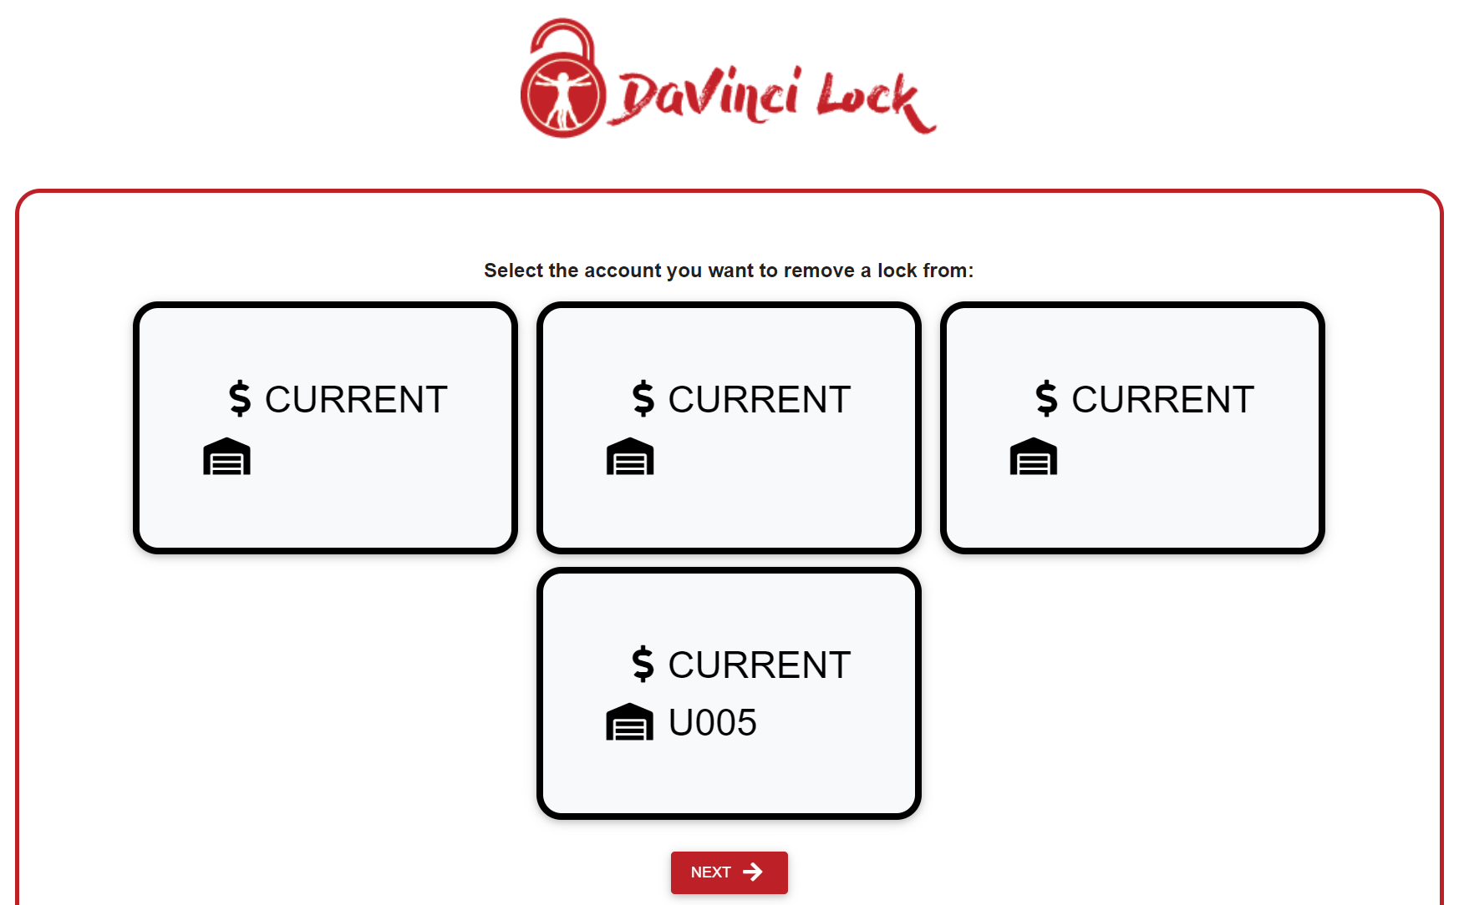

Follow the directions and enter the code on the lock

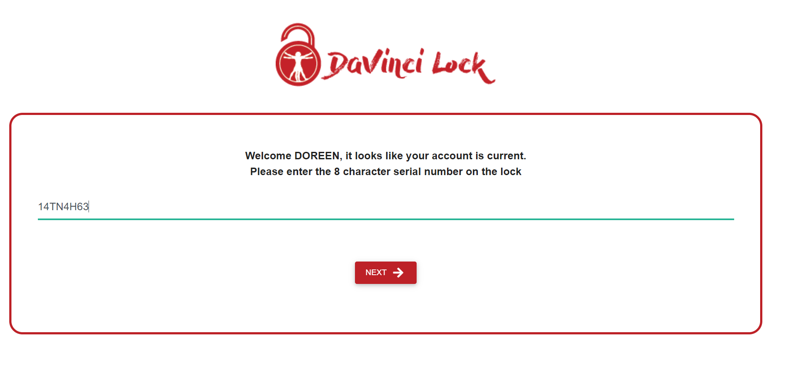

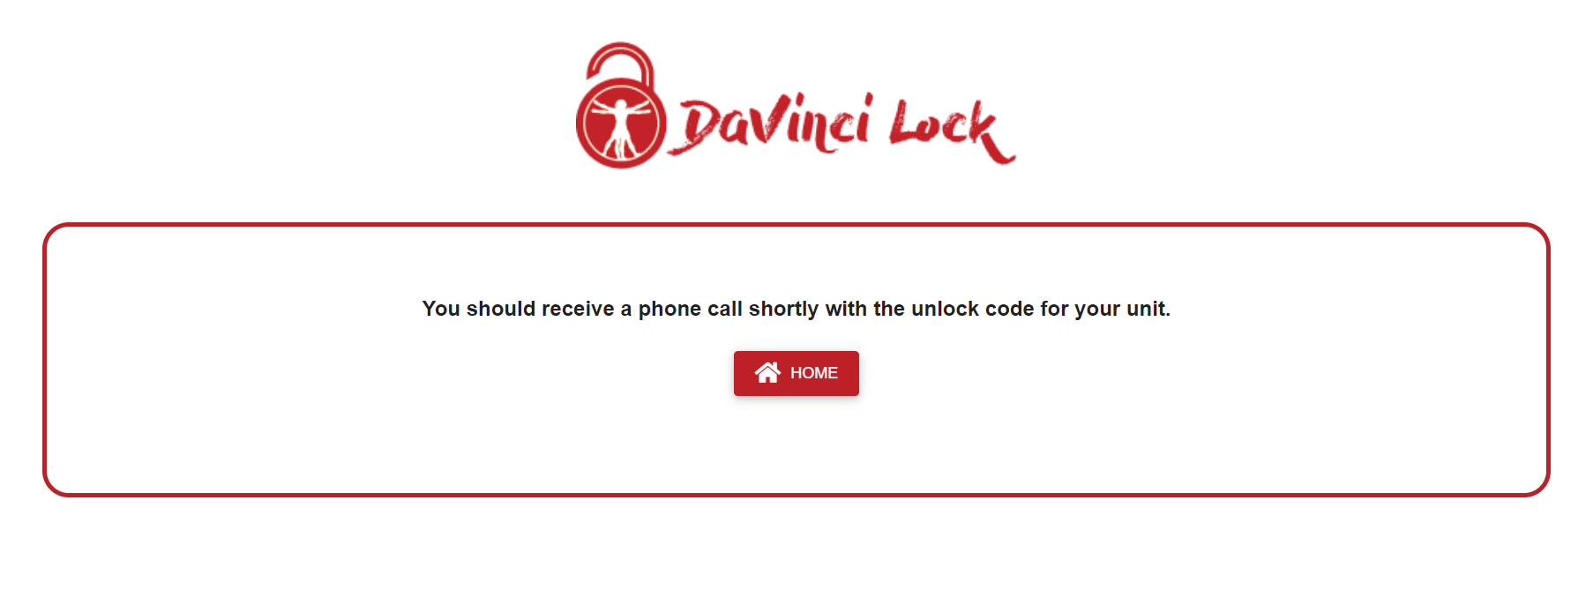

You will receive a phone call from a 919-area code, they will give you the release code on the lock

Then please place the over lock in the drop box located at this facility. If the lock is not returned there will be a$50.00 charge added to your account.

